System manual
for the
Sharp PC-E500
Pocket Computer

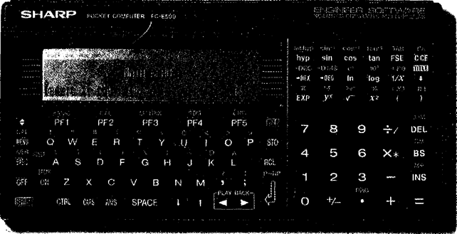
ISBN 3-89374-051-1 Dr. Joachim Stange
Fischel GmbH
Notes:
- The text is essentially the result of automatic translation from the German PDF.
- This document was created with LibreOffice.
- It must be viewed in Web Mode only!
A Abbreviations in the description of the commands
Registers

A Accumulator, 8 bit register
B Auxiliary accumulator, 8-bit register
BA Double register from B and A, 16-bit
C/Cy carry flag, 1-bit.
F Flag register, 8 bits
I I register, 16 bits
IL IL register, low byte of I, 8 bits
PC Program counter, 16 bit
PS Segment register, 4 bits
S S-register, 20-bit, stack pointer for CALL/RET
U U-register, 20-bit, stack pointer for data stack
X X register, 20 bits
Y Y register, 20 bits
Z Zero flag, 1 bit
Command lists
C Carry flag: C = Carry is changed
. = will not be changed
1 = 1 is set
0 = 0 is set
Zy number of cycles
Command words, as the last letter

L means block processing
LD means decrementing block transport
P means transfer of three bytes
W means word transfer
Command operands
K/k 1 byte, for address or immediate
L/l 1 byte, for address or immediate
M/m 1 byte, for address or immediate
N/n 1 byte, for address or immediate
R/r One register: A, IL, BA, I, X, Y, U, S
R₁/r₁ One 1-byte register: 0=A , 1=IL
R₂/r₂ One 2-byte register: 2=BA , 3=I
R₂/r₃ One 3-byte register: 4=X , 5=Y , 6=U , 7=S
(*) Contents of the internal RAM address given by *
[*] Contents of the external RAM address given by *
& The character & in front of a hex number is generally not used,
since only hex numbers are used in connection with the commands

12.0 The PC-E500 microprocessor and its architecture

The CPU of the PC-E500 is an 8-bit CMOS CPU and is named SC-62015B01 according to the service manual.

The address space for the external RAM/ROM is 1 Mbyte. This means that the addressing is done with 20 bits or 5 hex digits.

A CPU internal, internal RAM has 256 bytes.

The cycle time was measured via the WAIT command at around 1.3 microseconds.

The architecture of the CPU

The CPU registers

There are 1-bit, 8-bit, 16-bit and 20-bit registers:
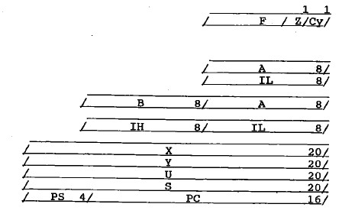
F flag
Z zero flag
Cy Carry flag
A accumulator
IL Counter, low
BA Auxiliary Accumulator with accumulator
I counter
X pointers
Y pointer
U data stack pointer
S CALL Stack pointer
PC program counter 16 bits = 64KB
PS segment reg. 4 bits = 16 segments

1-bit register
Z, the zero flag, is set to one for arithmetic/logical functions if the result was zero. If the result was not zero, the zero flag is set to zero.
Cy, the carry flag, is set to one for arithmetic functions if there was an overflow or carry, and set to zero otherwise.
Both registers are combined in the flag register, F, and can thus be pushed onto the stack or fetched from there.

/ 0 / 0 / 0 / 0 / 0 / 0 / Z/ Cy/
8-bit register

A, the accumulator, is the main register where the results of arithmetic or logical operations often appear.

B, the auxiliary accumulator, can only be addressed together with the accumulator as a double register BA.

IH is the high-order byte of the 2-byte register I. It can only be addressed together with IL.

IL is the least significant byte of the 2-byte register I. It can be addressed individually. If it is loaded with an immediate, then IH gets the value zero.

F flag register.

16-bit register

BA combines the auxiliary accumulator, B, and the accumulator, A, as a double register.

I is a 16-bit counter whose least significant byte can be individually addressed as IL.

20-bit register

X and Y are 20-bit pointers. You can directly address the external RAM with its address range of sixteen 64KB segments.

U is the stack pointer for data that is pushed/fetched onto the U stack with the PUSHU-/POPU- instructions.

S is the stack pointer for the return addresses of the CALL/RET commands.
When returning from a machine program to the basic interpreter, both stack pointers, U and S, must have the same value as before the machine program was run.

PC is the 16-bit program counter which, together with the 4-bit page segment register, PS, i.e. a total of 20 bits, can address the memory space of 1 Mbyte.

Registers of the internal CPU-RAM

There is 256 bytes of CPU internal RAM. Of these, 236 bytes (addresses 00 - ec) are freely available. The remaining 20 (address ec -ff) are reserved for special one-byte registers, of which (ec) = BP, (ed) = PX and (ee) = PY are special pointers for the internal RAM.

ec = BP = base pointer for internal RAM
ed = PX = PX pointer for internal RAM
ee = PY = PY pointer for internal RAM
ef = AMC = Address Modify Control
f0 = KOL = Key Output Buffer
f1 = KOH = Key Output Buffer
f2 = KI = Key Input Buffer
f3 = EOL = E Port Output Buffer
f4 = EOH = E Port Output Buffer
f5 = EIL = E Port Input Buffer
f6 = EIL = E Port Input Buffer
f7 = UCR = UART Control Register
f8 = USR = UART Status Register
f9 = RXD = UART Receive Buffer
fa = TXD = UART Transmit Buffer
fb = IMR = Interrupt Mask Register
fc = ISR = Interrupt Status Register
fd = SCR = System Control Register
fe = LCC = LCD Contrast Control
ff = SSR = System Status Register

12.1 The Instruction Set

The instruction set of the CPU is quite extensive. Not only the 256 possibilities of the 8-bit code are used, but there are also multi-byte commands.

The instruction set of the CPU can be divided into the following groups:

- Transport commands
- Load the registers of the CPU or the internal RAM with numerical values, immediate
- Transport between the registers of the CPU
- Transport inside the internal RAM
- Transport between the CPU registers and the internal RAM
- Transport between the CPU registers and the external RAM
- Transport between the internal RAM and the external RAM
- block transfer
- Transport between the registers of the CPU and the stack
- jump commands
- Subprogram commands
- Addition/subtraction commands
- Pointer addition commands
- Increment/decrement commands
- Logical commands
- Bit test commands
- Compare commands, Compare
- Carry flag control commands
- Swap- Rotate- Shift- commands
- Reset and interrupt commands
- CPU control commands

These groups of machine instructions are described below in a condensed form.

For a detailed description with numerous examples, please refer to the machine language manual. A disassembler and a breakpoint monitor for testing self-developed machine programs are also printed there. It also covers the machine routines for operating the display, keyboard, and printer.

12.2 The address space

The internal RAM

The internal RAM is 256 bytes. Of these, 236 (00 - eb) are freely available. The remaining 20 (ec - ff) are reserved for special registers.

00 - eb freely usable
ec - ff special registers

The external RAM

The program counter (including the PS register) has 20 bits. The memory area that can be addressed by the program counter is therefore sixteen 64K segments. This corresponds to an address space of one MByte, which can be represented by five hex positions or 2.5 bytes.

From this area are reserved:

00000 – 03FFF SH-26 display
04000 – 07FFF another display area
. . . . .
. . . . .
. . . . .
FFFFA Interrupt vector, low byte
FFFFB Interrupt vector, high byte
FFFFC Interrupt Vector, Extension(Segment)
FFFFD Reset Vector, low byte
FFFFE Reset vector, high byte
FFFFF Reset Vector, Extension(Segment)

12.3 Addressing

The addressing in the internal RAM

The 256 (decimal) registers of the internal RAM can be addressed in different ways. Since they are addressed via their addresses, round brackets ( ) are always used.
The content of a memory location in the external RAM, on the other hand, is indicated by the address set in square brackets [ ].

The addressing in the internal RAM can be done directly by a byte or relative to the pointer BP (Base Pointer), PX or PY.

(*) means any of the following addresses:
(n) direct addres
(BP+n) adress = BP + n. IF BP + n > ff, adress = BP + n - 100
(PX+n) adress = PX + n. IF PX + n > ff, adress = PX + n - 100
(PY+n) adress = PY + n. IF PY + n > ff, adress = PY + n - 100
(BP+PX) adress = BP + PX. IF BP + PX > ff, adress = BP + PX - 100
(BP+PY) adress = BP + PY. IF BP + PY > ff, adress = BP + PY - 100

PY is used in the second argument of a command if PX already occurred in the first argument.
The usual addressing type is (BP + n), it does not require a prefix. All others are determined by a prefix. A prefix increases the cycle count by one.

The addressing in the external RAM

The memory space of 1 Mbyte in external RAM is addressed with 20 bits or five hex digits.

Addressing can be direct, using a number, or indirect, using the content of a register. Furthermore, it can be short, near or far.

Short means addressing with one byte (two-digit hex number or 8-bit register) relative to the program counter by plus/minus 255.

Near means addressing with two bytes (four-digit hex number or 16-bit register) in the memory segment specified by the first hex position of the program counter (PS register).

Far means addressing with 2.5 bytes (five-digit hex number or 20-bit register), i.e. addressing in the entire addressable memory area.

Either a 3-byte CPU register or three consecutive registers of the internal RAM can be used for indirect addressing.

With indirect addressing via a 3-byte CPU register, the register content can also be incremented (after the command has been executed) or decremented (before the command has been executed) when the command is executed. Furthermore, the address can also be given by the register content plus or minus an offset:

[*] means one of the following addressing:
[lmn] Content of the memory cell with the address lmn, the first four bits of l are ignored.
[r₃] Content of the memory cell whose address is given by the content of a 3-byte register (20 bits): 4=X , 5=Y , 6=U , 7=S.
[r₃++] Content of the memory cell whose address is given by the content of a 3-byte register (20 bits): 4=X , 5=Y , 6=U , 7=S.
After the command has been executed, the content of the register is increased accordingly:
With 1-byte transfer, by 1.
With 2-byte transfer, by 2.
With 3-byte transfer, by 3.
[- -r₃] Content of the memory cell whose address is given by the content of a 3-byte register (20 bits): 4=X , 5=Y , 6=U , 7=S.
Before the instruction is executed, the content of the register is decremented accordingly:
With 1-byte transfer, by 1.
With 2-byte transfer, by 2.
With 3-byte transfer, by 3.
[r₃+n] Content of the memory cell whose address is given by the content of a 3-byte register (20 bits) increased by n.
[r₃-n] Content of the memory cell whose address is given by the content of a 3-byte register (20 bits) reduced by n.

In case of indirect addressing through three bytes of the internal RAM, these three bytes are used in reverse order. The first byte is the low byte of the address, the second byte is the medium byte and the third byte is the high byte. For the latter, the first four bits are ignored. The pointers of the internal RAM or an offset can be used:

[*] means one of the following addressing:
Content of the memory cell whose address is given by the three cells of the internal RAM starting at:
[(n)] n in the order: low, medium, high address byte.
[(BP+n)] BP+n in the order: low, medium, high address byte.
[(PX+n)] PX+n in the order: low, medium, high address byte.
[(PY+n)] PY+n in the order: low, medium, high address byte.
[(BP+PX)] BP+PX in the order: low, medium, high address byte.
[(m)+/-n] m in the order: low, medium, high address byte. The address obtained in this way is increased/decreased by n.
[(BP+m)+/-n] BP+m in the order: low, medium, high address byte. The address obtained in this way is increased/decreased by n.
[(PX+m)+/-n] PX+m in the order: low, medium, high address byte. The address obtained in this way is increased/decreased by n.
[(Py+m)+/-n] PY+m in the order: low, medium, high address byte. The address obtained in this way is increased/decreased by n.
[(BP+PX)+/-n] BP+PX in the order: low, medium, high address byte. The address obtained in this way is increased/decreased by n.

Example for [(m)+n]
Let: [63510] = A7
Let: (08) = 12, (09) = 34, (OA) = 56
MV A,[(08)+FE] results in: A = [63412+FE] = [63510] = A7

12.4 Brief description of the commands

Abbreviation for the CPU registers

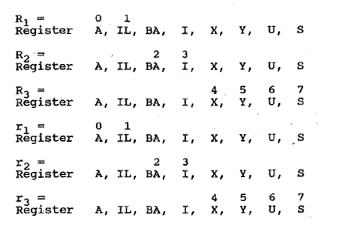

The prefixes for the different types of addressing in the internal RAM are:

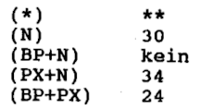
For the prefix, **, given only one argument from internal RAM:
no
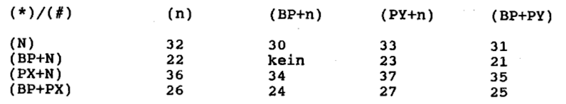
For the prefix, *#, given two arguments from internal RAM:
A prefix increases the cycle count by one.

Immediate instructions, load the registers of the CPU or the internal RAM with numerical values

Load a CPU register

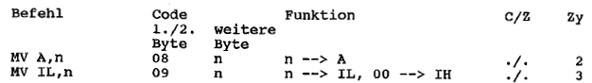
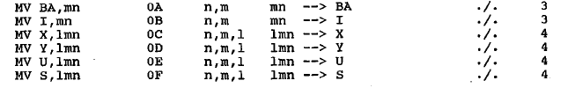
Load a register of internal RAM

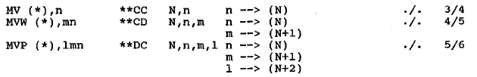
Transport between the CPU registers

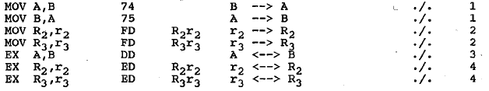

Transport between the registers of the internal RAM

Transport of one byte

Transport of two bytes (word)

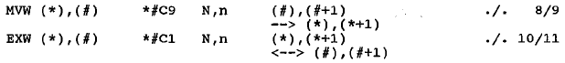

Transport of three bytes
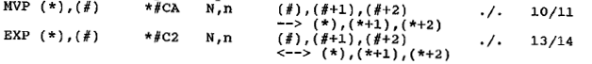

Block transport

Incremental block transport

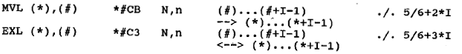

Decremental block transport

Transport between CPU registers and internal RAM

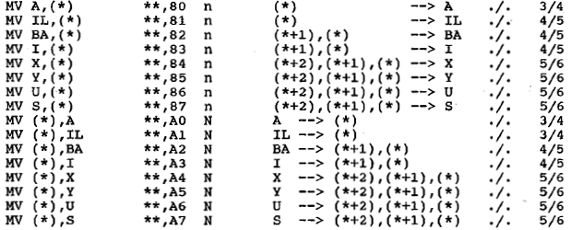

Transport between CPU registers and external RAM locations

Transport: CPU registers to external RAM (directly addressed)

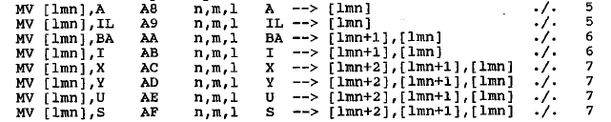

Transport: External RAM (directly addressed) in CPU registers

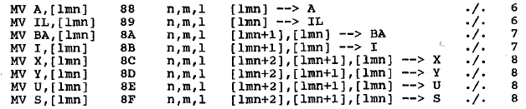

Transport: CPU registers to external RAM (indirectly addressed)

1-byte source
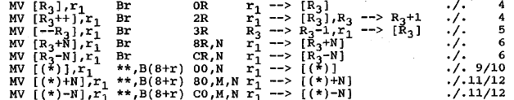

2-byte source
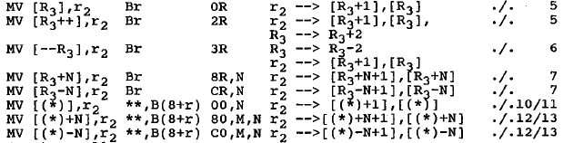

3-byte source
For a 3-byte destination, r₃ = S is not permitted
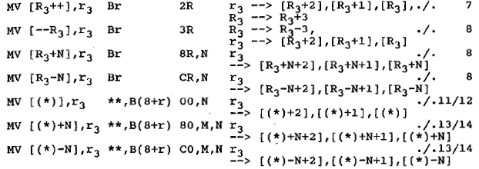

Transport: External RAM (addressed indirectly) into CPU registers

1-byte destination
For IL one cycle more
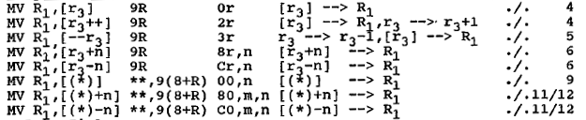

2-byte destination
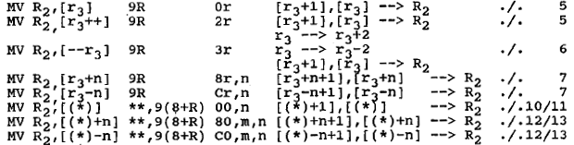

3-byte destination
For a 3-byte destination, R₃ = S is not permitted
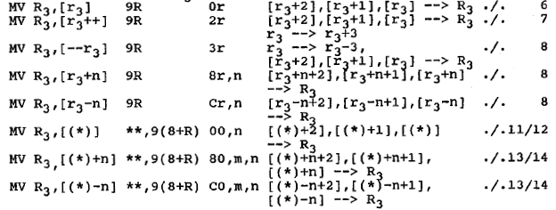

Transport between the registers of the internal RAM and the external RAM
Transport from internal RAM to external RAM (directly addressed)
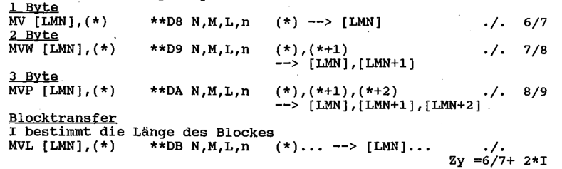

I determines the length of the block

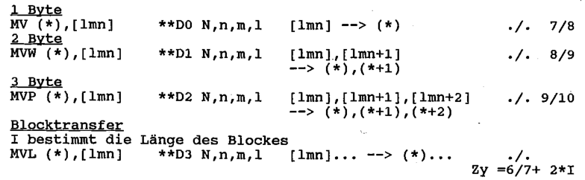
Transport from external RAM (directly addressed) to internal RAM
I determines the length of the block
Transport from internal RAM to external RAM (indirectly addressed)

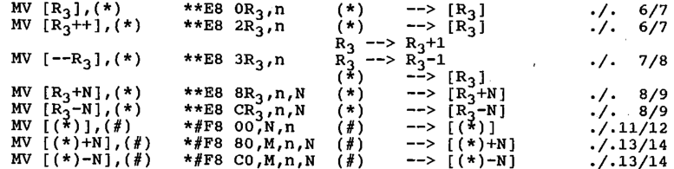
1-byte
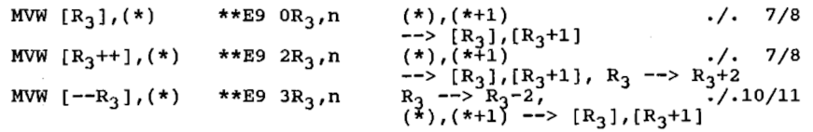
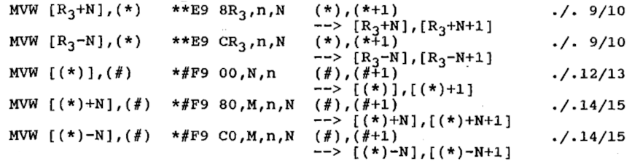
2-byte

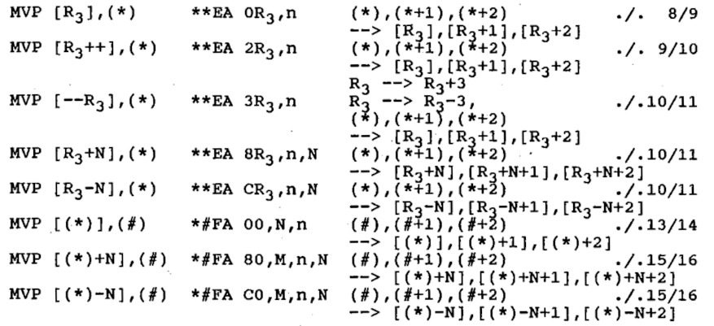
3-byte
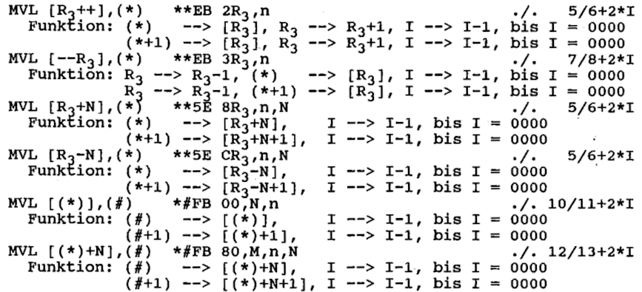
Block transfer
I determines the length of the block
MVL [ R₃ ] , ( * ) you use: MVL [ R₃ + 0 ] , ( * )
Transport from external RAM (indirectly addressed) to internal RAM

1-byte
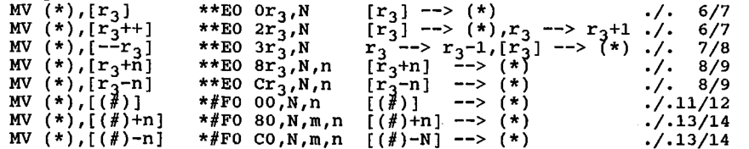
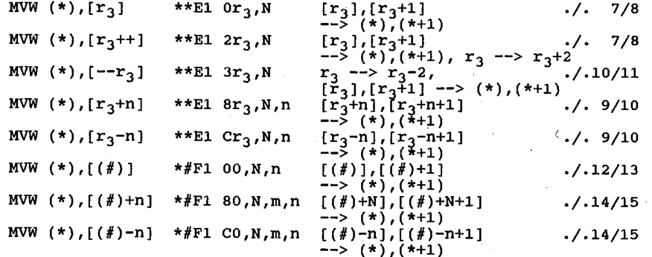
2-byte
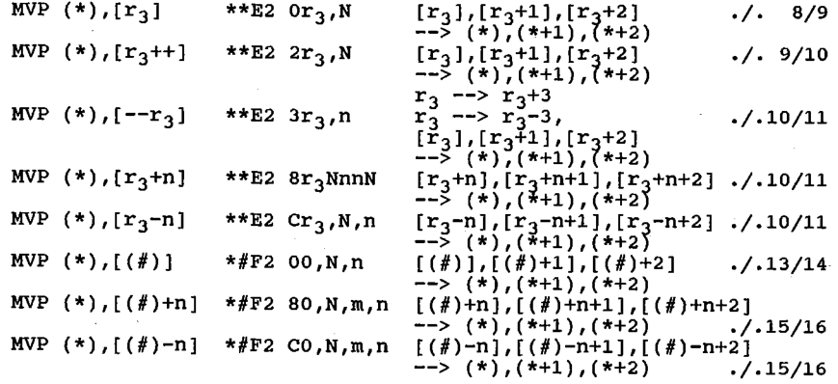
3-byte

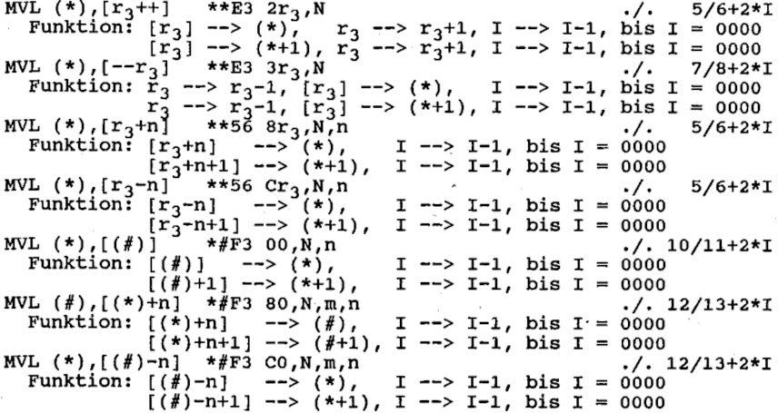
Block transfer
I determines the length of the block
MVL ( * ) , [ R₃ ] you use: MVL ( * ) , [ R₃ + 0 ]

Transport between CPU registers and the stack

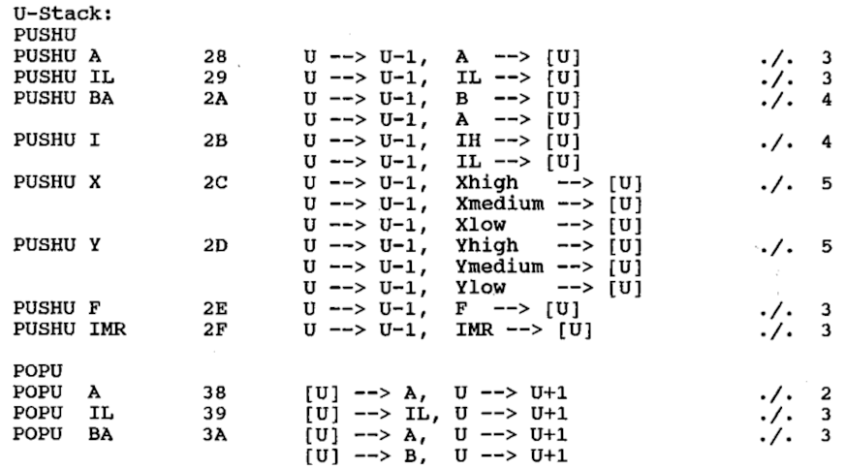

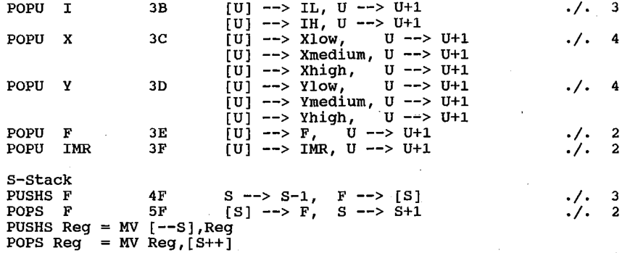

Jump commands

Direct far jump
1st Hex place without meaning
Indirect far jumps
Unconditional near jump
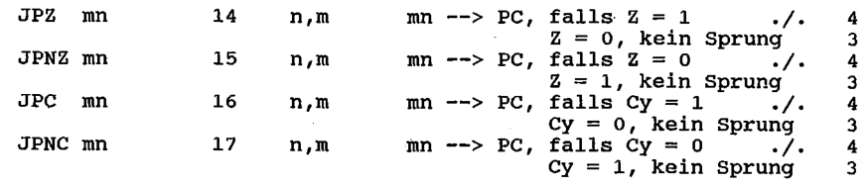
Conditional near jumps
if

no jump

Unconditional relative short jumps

PC after the JR command
Conditional relative short jumps
if
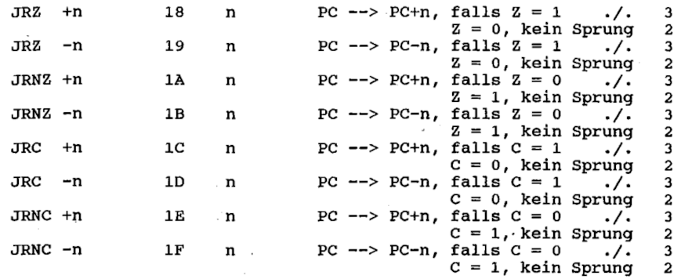
no jump

Subprogram commands

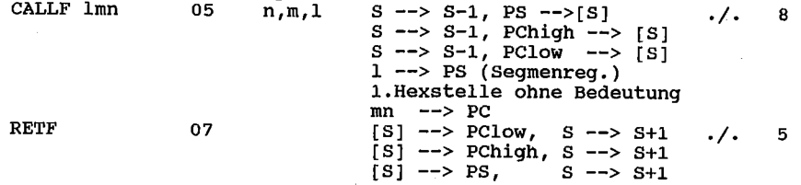
Far-CALLF/RETF
1st Hex place without meaning
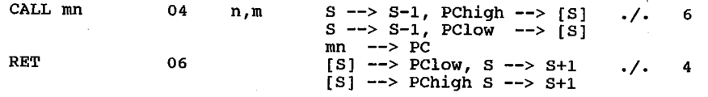
Near-CALL/RET

Additions/substractions commands

Addition/subtraction of an immediate
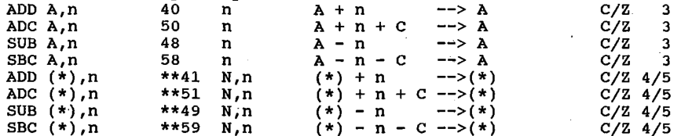

Addition/subtraction between the accumulator and the internal RAM
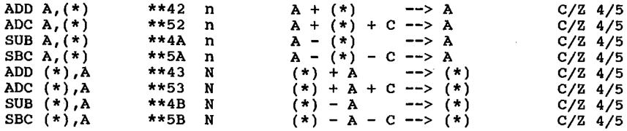

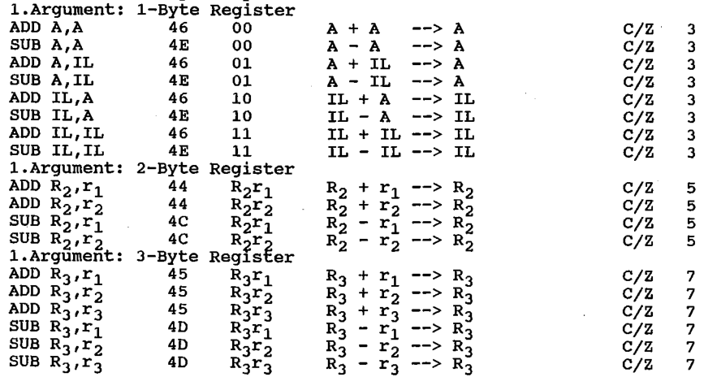
Addition/subtraction between CPU registers

Binary block addition/subtraction, accumulator to/from a block in internal RAM
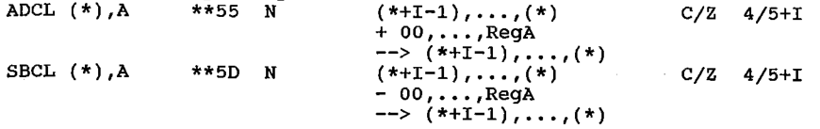

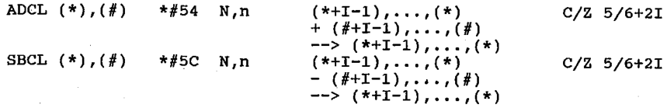
Binary block addition/subtraction of a block in internal RAM to/from another block in internal RAM

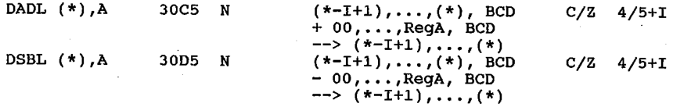
Decimal block addition/subtraction, accumulator to/from a block in internal RAM

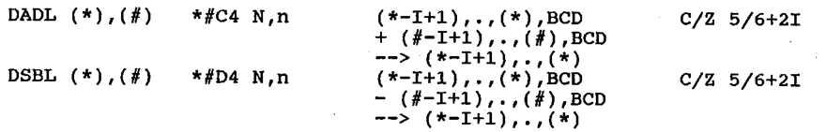
Decimal block addition/subtraction from one block in internal RAM to/from another block in internal RAM

Pointer addition commands
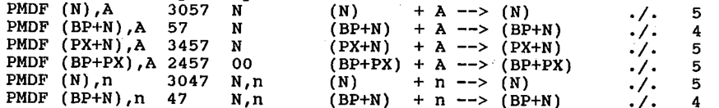
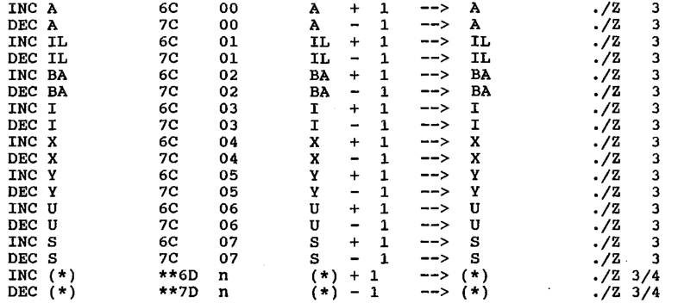
Increment/decrement commands

Logic commands
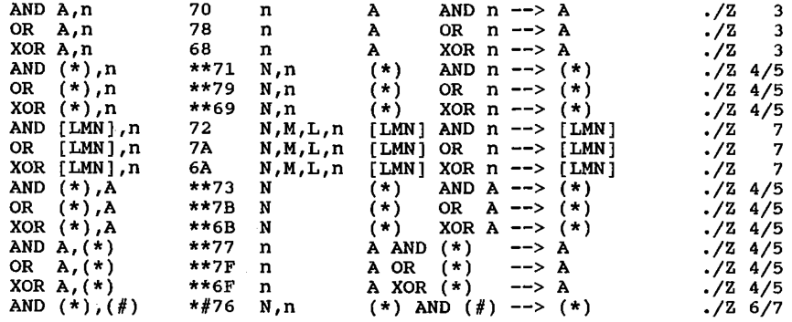

Bit-test commands

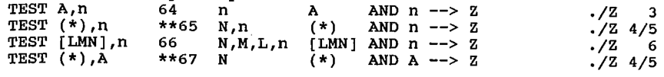

Comparison commands

Compare with immediate

Compare internal RAM with CPU register
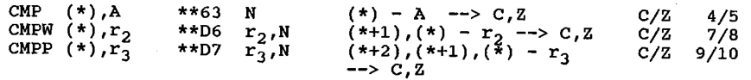

Compare internal RAM with internal RAM
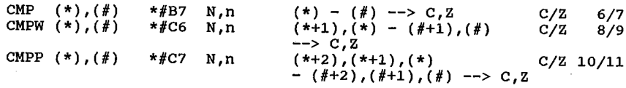

Carry flag control commands

Swap, rotate and shift commands

Digit-swap command
Bit-rotate commands
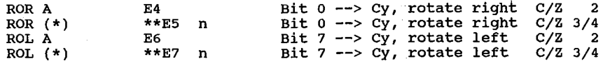
Bit-shift commands
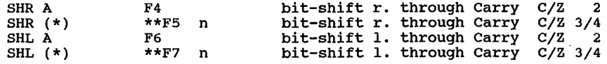

Digit-shift commands

Reset and interrupt commands

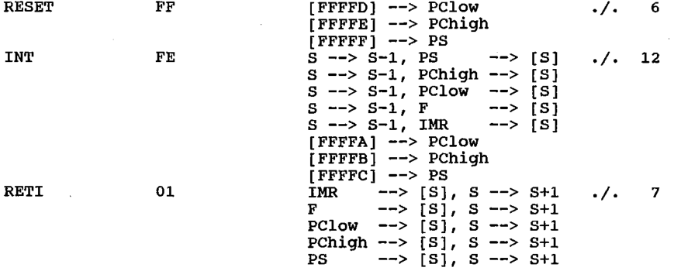

CPU control commands
NOP 00 no operation . / . 1
WAIT EF 1 + I wait cycles . / . 1 + I
TCL CE Reset timer . / . 1
HALT DE Stop, sub-timer keeps running.
On pin high, 1 pin(K0 to K7) high,
sub timer overflow or IRQ at bit 7 of FD = 1
cause execution of the next command.
Reset pin high causes RESET.
OFF DF Stop.
On pin high, 1 pin(K0 to K7) high or IRQ at bit 7 of FD = 1
causes the next command to be executed.
Reset pin high causes RESET.

13.0 Structure and call of machine programs

At the very beginning, an important point should be pointed out, which is explained in more detail at the end of this section:
The carry flag must be reset before a machine program returns to the basic interpreter, otherwise a nonsensical error message appears or the PC-E500 gets out of control and the RESET button must be pressed.
Machine programs can be called with the basic command CALL both in RUN mode, i.e. directly from the keyboard, and from a basic program.
The basic commands PEEK, POKE, CSAVEM and CLOADM are used to create and save machine programs. With PEEK you can view the memory content directly. POKE allows numbers (0 to 255 decimal) to be entered into memory locations. With CSAVEM or CLOADM, machine programs, more precisely the contents of memory areas, can be saved on cassette or loaded from cassette into RAM. Since these commands are not included in the PC-E500 Instruction Manual, they are described in the following section.
Programming in machine language requires a memory area that is not disturbed by basic programming or other functions of the PC-E500. This reserving of memory space for programming machine programs is also described in one of the next sections.
The machine program itself is built up from machine instructions described in the chapter on machine language. To return to the basic interpreter, either to the keyboard or to the calling basic program, two machine commands are required at the end of the machine program. These are the RC (Reset Carry, code 9F) and RETF (Return Far, code 07) commands.
13.1 Basic commands for machine programming
The commands PEEK, POKE, CALL, CSAVEM and CLOADM are available in the Basic interpreter for entering machine programs, calling them up from a basic program or from the keyboard and storing them on a cassette.
The basic commands SAVE and LOAD should also be usable by appending M in the same way as CSAVE and CLOAD for saving and loading machine programs.
PEEK
PEEK numeric expression
The content of the memory cell whose address is given by the numeric expression is called up.
POKE
POKE numeric expression 1, numeric expression 2, numeric expression 3,
Starting at the memory address given by numeric expression 1, the following numeric expressions are placed into memory.
CALL
CALL numeric expression
The machine program is started, the start address of which is given by the numerical expression. To return to the basic interpreter from the machine program, this must be terminated with the commands RC (Reset Carry, Code 9F) and RETF (Return Far, Code 07).
CSAVEM
CSAVE M text expression, numeric expression 1, numeric expression 2, numeric expression 3
The text printout is not necessary. The machine program whose start address is given by numeric expression 1 and whose end address is given by numeric expression 2 is stored on the cassette under the name given by the text expression. If the numerical expression 3 is specified, the machine program is started at this address after CLOADM if RUN mode is set.
CLOADM
CLOAD M Text expression, numeric expression
The text printout is not necessary. This means that a program can be read back into the computer without specifying the name, even if it was saved on the cassette under a name. However, if another name is specified, the program will not be read. The numeric expression is not strictly necessary. If the machine program is to be read into the same memory area from which it was written to the cassette, the numeric expression need not be specified. You only have to specify the start address if you want to read into another memory area.
Examples:
CSAVEM &BF000,&BF3FF,&BF000
saves a machine program in the area &BF000 to &BF3FF on cassette. The last specification of &BF000 ensures that the program is started immediately after loading the program with CLOADM from the cassette.
CLOADM
loads the machine program saved with the previous command to &BF000 to &BF3FF and starts it at address &BF000 (corresponds to CALL &BF000) if RUN mode is switched on.
CSAVEM "PRO1",&BF800,&BF8FF
saves a machine program in the area &BF800 to &BF8FF under the name "PROl" on a cassette.
SAVEM"E:MA",&BFA00,&BFAFF
saves the memory area from &BFA00 to &BFAFF under the name "MA" on the ramdisk E:.
LOADM"E:MA",&BF900
Loads the program saved with the previous command into the memory area from &BF900 to &BFAFF.

13.2 Provision of memory space for machine programs
If you want to develop machine programs, you need a memory area that is not disturbed by other uses of the pocket computer, e.g. basic programming. This reservation of storage space is described below.
The following entry in RUN mode (termination with the return key) frees a memory area in front of &BFC00:
POKE &BFE03,&1A,&FD,&0B,Y,X,&00:CALL &FFFD8
The start BEG of the freed memory space is determined by X and Y when poking in. It is:
BEG = &BFC00 - (&100*X + Y)
Also, the beginning BEG of this freed memory area is kept on system location &BFD1A/B/C. So it is:
BEG = PEEK &BFD1A + &100*PEEK &BFD1B + &10000*PEEK &BFD1C
Examples:
POKE &BFE03,&1A,&FD,&0B,&00,&08,&00:CALL &FFFD8
frees the area &BF400 to &BFBFF.
It is: PEEK&BFD1A + &100*PEEK&BFD18 + &10000*PEEK&BFD1C = &BF400
POKE &BFE03,&1A,&FD,&0B,&80,&0B,&00:CALL &FFFD8
clears the area &BF080 to &BFBFF.
It is: PEEK&BFD1A + &100*PEEK&BFD1B + &10000*PEEK&BFD1C = &BF080
POKE &BFE03,&1A,&FDA0B,&00,&10,&00:CALL &FFFD8
clears the area &BECOO to &BFBFF.
It is: PEEK&BFD1A + &100*PEEK&BFD1B + &10000*PEEK&BFD1C = &BEC00
Through
POKE &BFE03,&1A,&FD,&0B,&00,&00,&00:CALL &FFFD8
the status given after ON/RESET and deleting the memory is restored. In &BFD1A/B/C there is address &BFC00 in this initial state.
This freeing of a memory area does not have to be carried out after an ON/RESET. POKE/CALL input is also possible with an existing basic program. This is shifted forward accordingly if there is still enough storage space, which can be determined with FRE0.
The size of the memory area that can be freed depends on the existing RAM card (MEM$="B"). It may also be possible to replace the last &00 in the POKE expression with a number Z. It can be assumed that there is a shift of Z*10000. There was not enough RAM available for testing.

